Report Specification Guide
This document acts as a guide for completing the report request template. Each section in this document will describe and explain how to use the available fields in the template. Included in each section is a screenshot of the template with a completed example. Refer to this guide when you need help using the report request template.
Notes: In the template you will find fields colored in red, blue, and green.
- Red fields are required. The report cannot be completed without these fields in red.
- Blue fields are optional. The more optional fields that are completed, the easier it is for the report writer to create the report. This aids in speed and efficiency and reduces ambiguity.
- Green fields are only to be completed after the report is completed.
Please note the example screenshots do not include real names or report request details. It is not an actual report request. It is meant to act as a demonstration.

General Info Tab

Section 1 – Request
Report Name – Enter the name of the report for the new system. This is how the report will be identified. If this is a preexisting report, you may or may not want to re-use the Legacy Report Name.
Date Requested – This is the date the request is being made.
Requested By – This is the name of the person making the request.
Dept/Unit – This is the department or unit that is making the request. (i.. The department to which the requestor belongs.)
Date Required – This is the date by which the report is needed. Please allow a reasonable time for the request to be completed.
Contact Phone – The phone number of the requestor. The report writer may need to contact you with questions about the request.
Contact Email – The email of the requestor. The report writer may need to contact you with questions about the request.
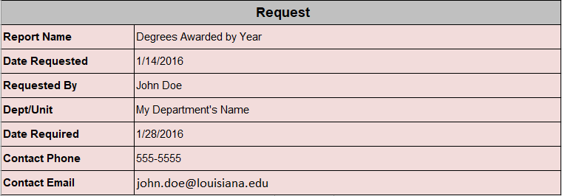

Section 2 – Purpose
Purpose – A brief description of the purpose of the report. The purpose of the report aids the report writer in understanding the intent of the report. It helps the report writer know here to access the appropriate data. The purpose also helps the report writer account for important details that may otherwise be overlooked.
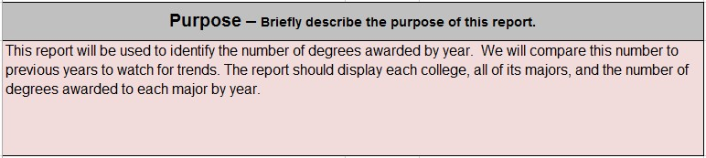

Section 3 – Usage
Internal – Select this option to indicate that the report will be used within the requestor’s department for day-to-day business operations.
External – Select this option to indicate that data from the report will be shared with other departments on campus or outside agencies other than UL Lafayette. If this option is selected, use the text box to list the outside departments/agencies to which the data will be disbursed, and explain the need to share the data.
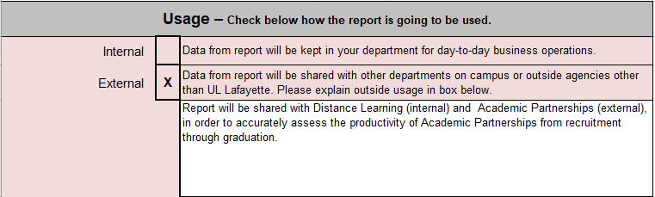

Section 4 – Distribution/Schedule
Schedule to run (Y/N)? – Indicates if the report should be scheduled to run at regular intervals. If applicable select yes or no (Y, N).
Run on Days of Week – Indicates the day of the week a scheduled report should run. If applicable, select a day of the week (Su, M, Tu, W, Th, F, Sa).
Frequency – Indicates the frequency at which the scheduled report should run. If applicable, select a time period (Daily, Weekly, Monthly, Quarterly, Annually, etc)
Run Time – Specifies the time of day a scheduled report should be run. This is important if certain processing must be done before the report can be run on the specified day. Make sure the run time is after said processing. If applicable, select a time (HH:MI AM).
Distribution Method – All reports are delivered electronically. The report will be emailed.
Distribute to – Allows you to enter the department, name, ULID, and email of the report recipient. This may be more than one person or more than one department. List all recipients by their department, name, ULID, and email address.

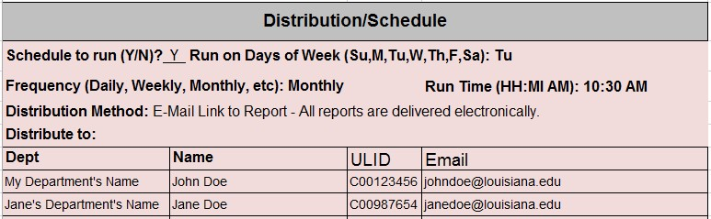

Section 5 – Report Type
List – Select this option to indicate that the report should be formatted as a list. A list is useful for displaying detailed information. A list may include totals and subtotals. Columns are predetermined.
Crosstab (Pivot Table) – Select this option to indicate that the report should be formatted as a crosstab. A crosstab is useful for comparisons, totals, and summaries shown in a grid format. Columns may be dynamically generated.
Chart – Select this option to display data in graphical form. A chart is a visual representation of your data. Sometimes using a chart makes data easier to consume and understand.
Excel – Select this option to have the results put in excel. This may allow you to manipulate the data or modify the report after it is completed.
PDF – Select this option of there is no intent to manipulate the data or modify the report. A PDF is often able to be formatted and made more visually pleasing. It cannot be edited.
CSV – Select this option to have a report in its raw data form. CSV files cannot be formatted as it is a flat table of data. Each data element is separated by a comma. This is a good option when there are no formatting needs and only the plain text is needed. This is be useful for large data files.
XML – XML is a text file that is imported into another system or application. It can contain formatting information that is displayed once imported. The formatting usually follows a template. The data is not typically manipulated or edited.

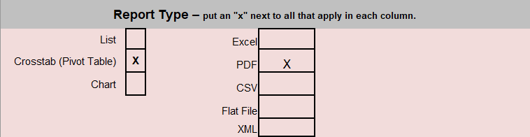

Section 6 – Data Validation Methodology
Describe how the report data will be validated – This is the method in which the data in the report will be tested for validity and accuracy. This usually comes in the form of a comparison to another source of the same data. It may be done by the report requestor or someone else.
Data Validation to be completed by – The name of the person to complete the data validation.
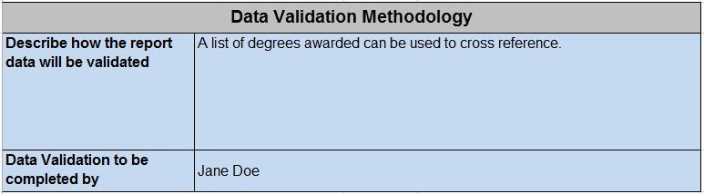

Section 7 – Report Signoff by Institution
Specification Signed off by – The name of the report writer who is creating the report. By signing off, the report writer is signifying that the report request contains adequate detailed information for the report to be completed effectively.
Specification Signoff method – The method in which the report is signed off by the report writer.
Final Signed off by – The final approval of the completed report, typically done by the requestor. This is only to be completed once the report is finished and the final report is approved as accurate and meets the criteria outlined by the report request.
Final Signoff method – The method in which the report receives final sign off.
Final Signoff date – The date on which the report receives final sign off.
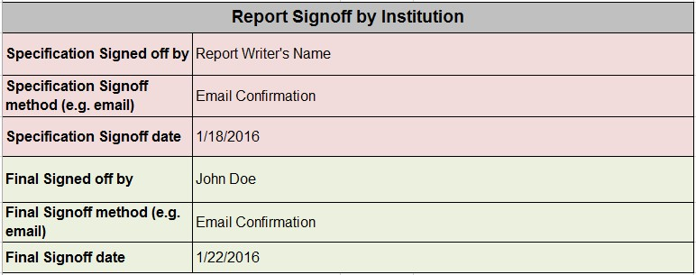

Data Elements Tab

Notes on style, layout, groups, totals, etc. – Include any notes, special requests, or instructions regarding the report format, styling of headings, numbers, text, etc. Include notes on groupings, totals, and sorting.

Legacy
Data Element – The data element from the legacy (previous) system. List the name of the field found on the pre-existing report. This identifies to the report writer the data as it appears in the legacy system.

Banner Forms
Form Name – The form name in either the legacy system or banner (either/or, not both). This identifies the form in which the data appears in the legacy or banner system.
Tab Name – If applicable, the tab name identifies where in the legacy or banner system the data resides.
Field Name – Lists the name of the field found on the legacy or banner form.

Banner Database
Column Name – The name of the column as it appears in banner. This helps the report writer match the data element from the legacy system to new system.

ODS
Reporting View – The view in which the data element can be found in the ODS.
Column Name – The name of the column in the reporting view of the ODS.
Display – A yes or no value (Y/N) to identify if the field in the report should be displayed in the output.
Filter – Indicates if a filter is needed and what the filter is for the appropriate fields.
Prompt for Value – Identifies which report fields should prompt the user for input at runtime.
Sort Order – Specify the fields in which the report should be sorted. Use numerical order to determine the sort priority.
Formula – The formula for any calculated fields should be placed here.
Notes – Additional info about a specific field should be entered here. Please be as descriptive as possible.
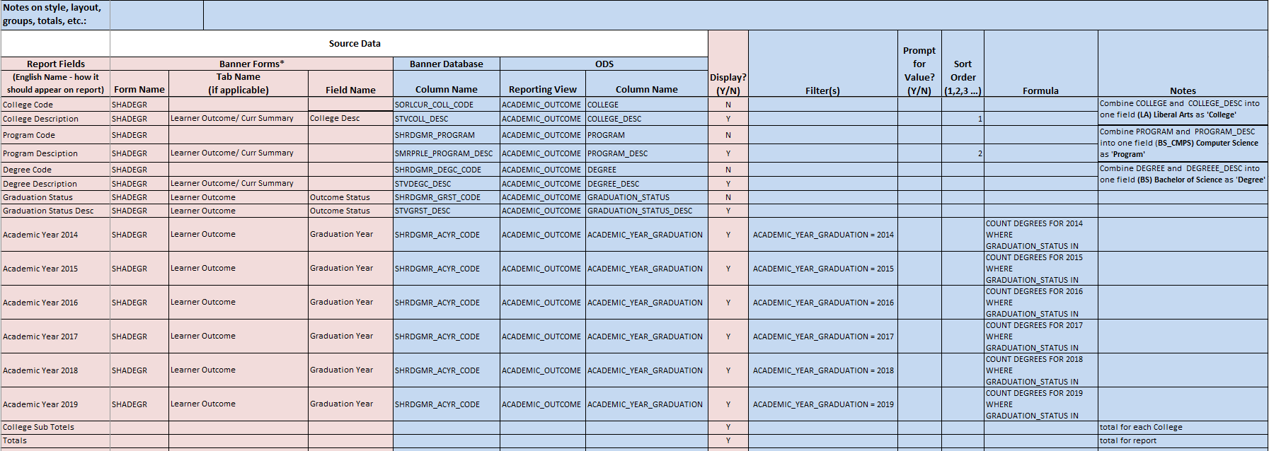

Sample Output Tab

Please provide sample output for the report. This can take the form of a report mockup created on this tab, a screenshot image pasted onto the tab, or reference to a report file provided separately. This should include any charts which are needed in the report.
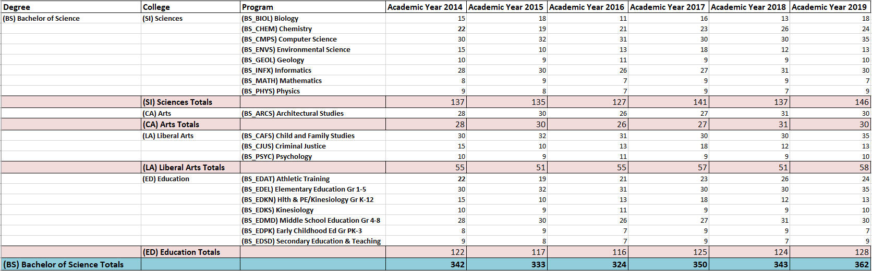

Test Data Tab

Please provide TEST DATA for the report. It is recommended that you have record(s) that meet the criteria of the requested report that we can use to validate output.
